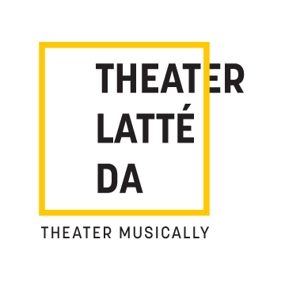
345 13TH AVE NE / MINNEAPOLIS, MN 55413 / 612-339-3003 / latteda.org

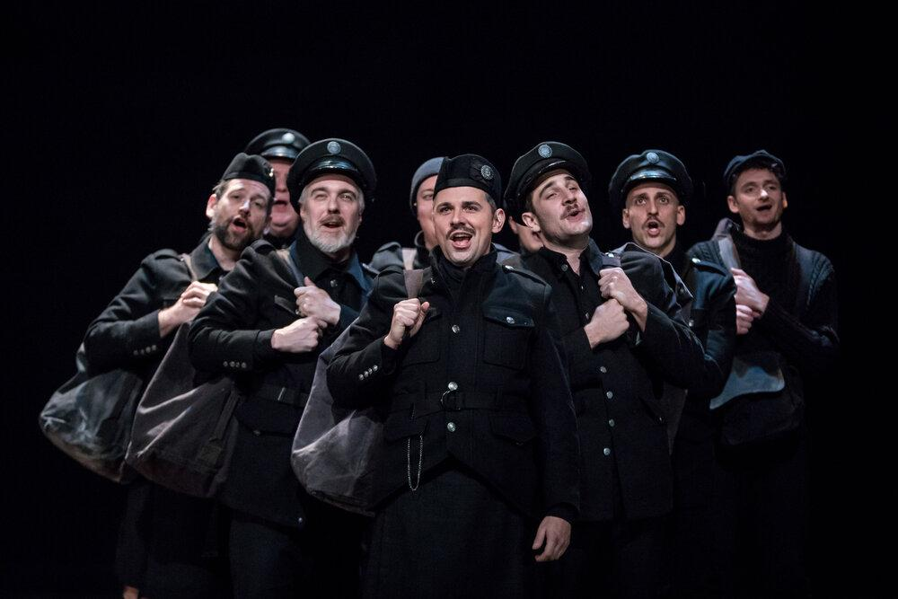
The cast of ALL IS CALM. Photo credit Dan Norman.

FOR IMMEDIATE RELEASE Contact: Andrew Leshovsky
Nov 30, 2020 andrew@latteda.org
612-767-5646 office

THEATER LATTÉ DA‘S AWARD-WINNING DOCU-MUSICAL
ALL IS CALM TO STREAM ON BROADWAYHD BEGINNING DEC 15

(MINNEAPOLIS/ST. PAUL) Theater Latté Da announces today All is Calm: The Christmas Truce of 1914, the poignant Drama Desk Award-winning docu-musical about the World War I Christmas truce, will be available to stream beginning Dec 15th on BroadwayHD, the online digital streaming service based in New York City. All is Calm premieres nationwide beginning Friday, November 27 on TPT Twin Cities PBS and will continue to debut in over 30 major markets across the country throughout the holiday season. BroadwayHD, known for being the only streaming service offering premium full-length stageplays and musicals offers more than 300 full-length video on demand productions.

Created by Theater Latté Da’s Founding Artistic Director Peter Rothstein, All Is Calm is a hybrid of documentary theater, weaving a capella period songs and firsthand quotes and letters from 30 World War I figures brought to life by 10 actors. The production features WWI patriotic tunes, trench songs, medieval ballads and Christmas carols from England, Wales, France, Belgium and Germany, with musical arrangements and vocal arrangements by Erick Lichte and Timothy C. Takach.

Filmed in 2019 at the historic Ritz Theater in Minneapolis through a partnership with Laura Little Theatrical Productions and Theater Latté Da, the production offers a look behind the camera with 20 minutes of behind-the-scenes footage including interviews with the docu-musical's creator, Theater Latté Da Founding Artistic Director Peter Rothstein, and members of the cast and creative team. Audiences will learn more about the historic moment in history, as well as how music, costumes and lighting bring to life the Drama Desk Award winning production.

Patricia Harrison, President and CEO of the Corporation for Public Broadcasting, attended the Off-Broadway run of ALL IS CALM in 2018 and felt the work should be shared nationally through public television. "ALL IS CALM reminds us through words, music and beautifully choreographed storytelling that when all is chaotic and it appears “the center will not hold,” it is still possible to find a connection to our shared humanity," shares Harrison.

All is Calm has toured the United States for ten seasons, reaching more than 50 cities playing prestigious venues such as The Kennedy Center (Washington, D.C.), Cal Performances (Berkeley, CA) and the Metropolitan Museum of Art (New York). The work has also been licensed and performed by theater companies, opera companies, and choruses in 30 different states, Canada, and Australia.

All Is Calm: The Christmas Truce of 1914 is a Theater Latté Da production in association with WNET. Written and directed by Peter Rothstein with vocal arrangements and music direction by Erick Lichte. Additional vocal arrangements by Timothy C. Takach. The production is produced by Theater Latté Da and directed for television by W. J. Lazerus with executive producers Laura Little and W. J. Lazerus. Original production funding for All Is Calm: The Christmas Truce of 1914 is provided by the Corporation for Public Broadcasting.

BroadwayHD introduces award-winning theater from all across the globe with both classic and modern productions. Fans can expect to see the full works of Shakespeare, awe-inspiring performances from Cirque du Soleil and a selection of the world's greatest musicals including Kinky Boots, Cats, She Loves Me, 42nd Street, The Phantom of the Opera, The King and I, The Sound of Music and An American in Paris. To learn more about BroadwayHD, visit broadwayhd.com.

Theater Latté Da is an award-winning Twin Cities musical theater company that combines music and story to illuminate the breadth and depth of the human experience. The company seeks to create new connections between story, music, artists, and audience by exploring and expanding the art of musical theater. www.latteda.org

###

